Membership registration

Referring to the figure for “Sign-up page”, all the header and footer elements from the main page is preserved for consistency. Besides that, a link to the FAQ on the “Issues on sign-up” section is provided to the user to encourage the users to troubleshoot before reaching for support. Moreover, a server status image is presented at the right side of the “Sign-up” heading to allow users to quickly check server status before logging in to avoid potential server issues. The sign-up form is squeezed and separated into two columns to allow the “Sign-up benefits” section to be seen on small screens, encouraging the user to sign-up.

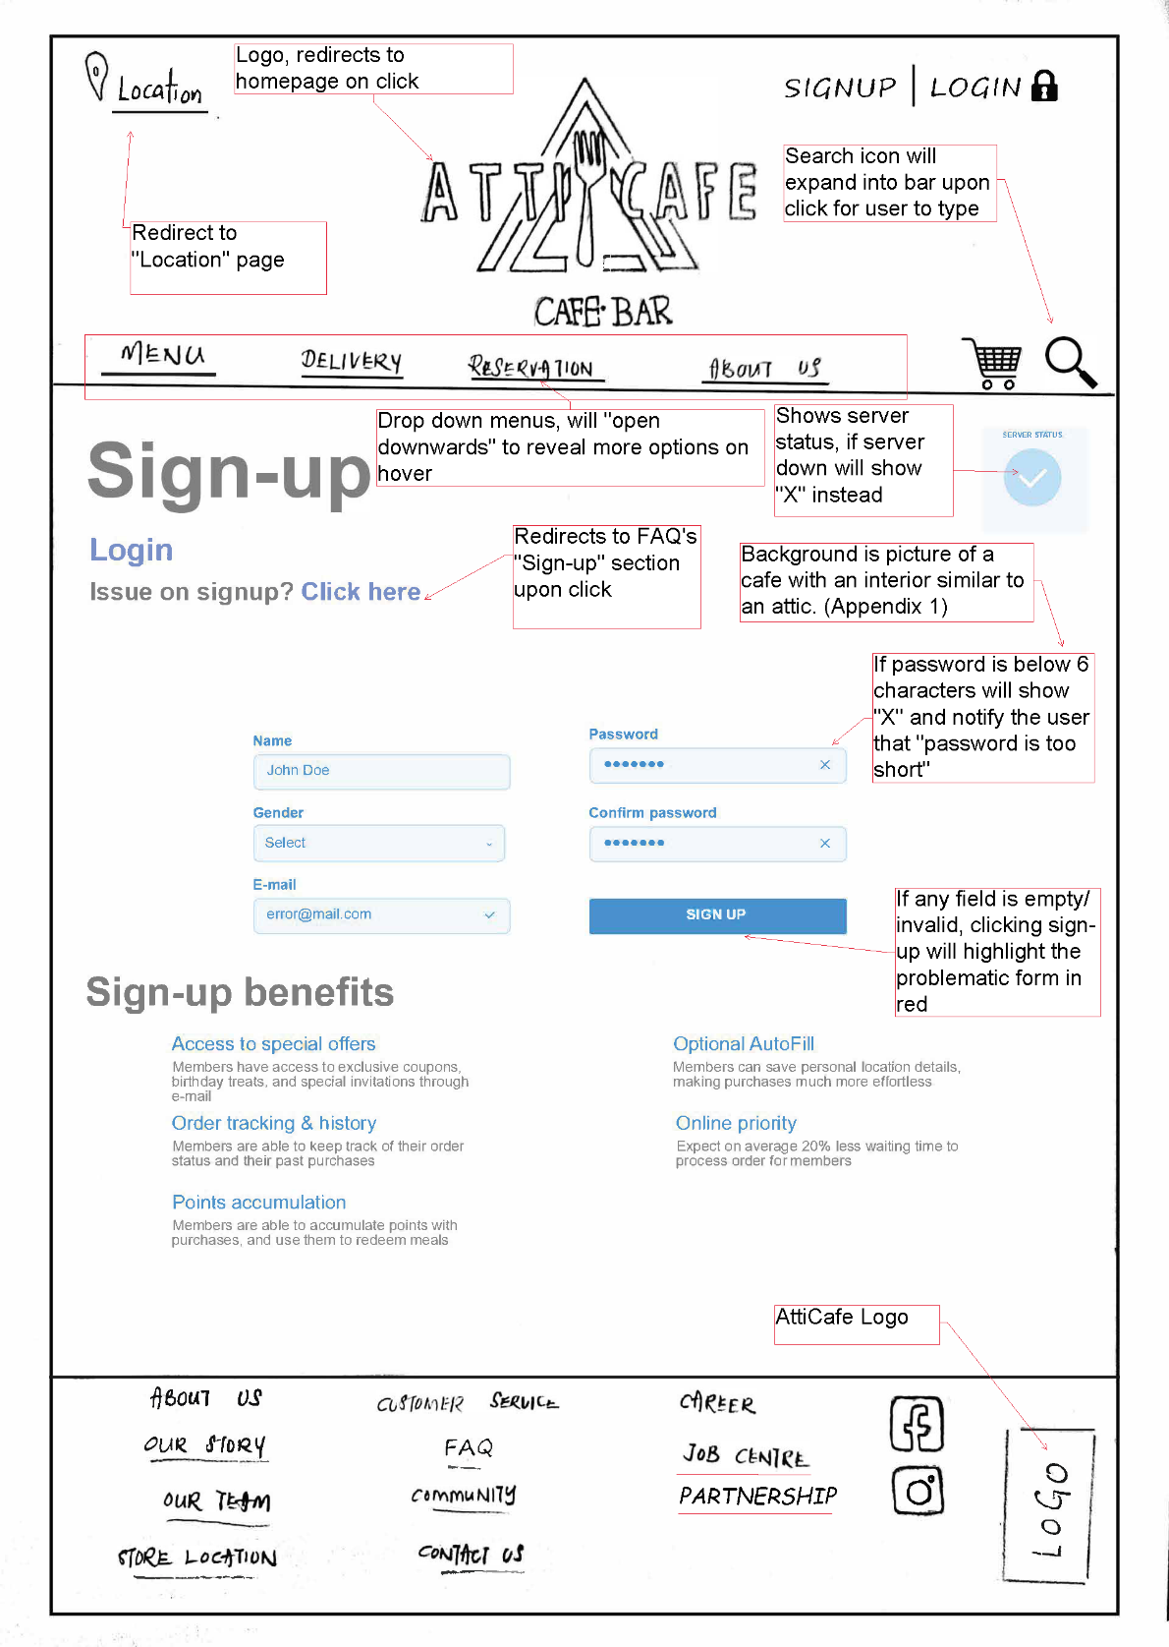

Membership profile

Referring to the figure for “Membership profile” page, like other pages, the header and footer elements from the main page is preserved for consistency. However, the “Login | Register “ icon is replaced by the member’s username and the logout button, to allow the user to sign out. A box stretching across the screen, containing points accumulation and order details is displayed below the title. This is to allow the user to quickly check their accumulated points and total orders to verify accuracy of transactions. Besides that, the points accumulated figure also entices them to purchase more. Member details are displayed directly below the “quick info” bar. Address fields are freely modifiable for the AutoFill function during orders. Users may change password by first typing their old password to prevent unauthorized changes especially when the user forgets to logout from their account in public places.

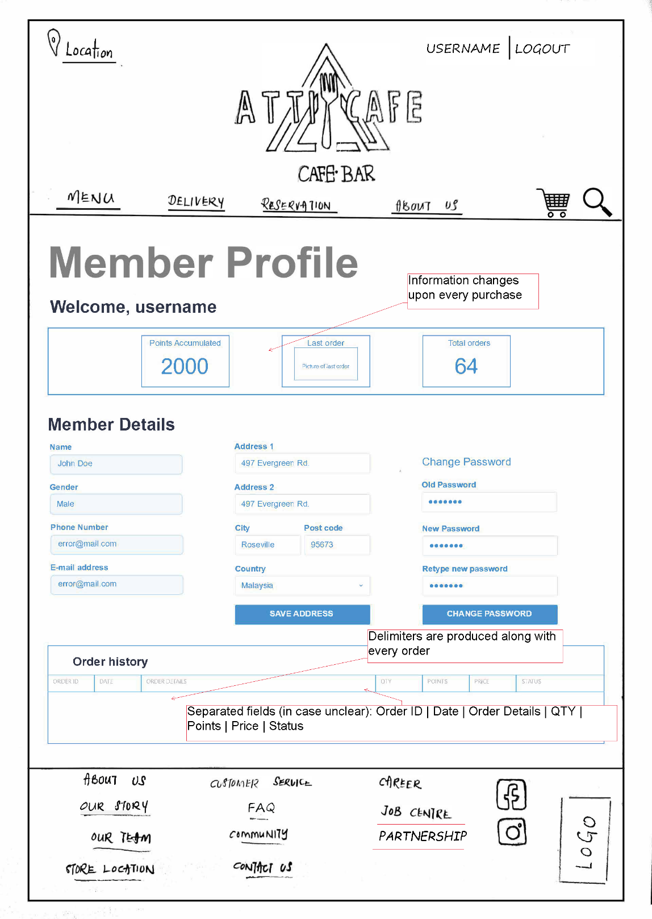

Membership Login

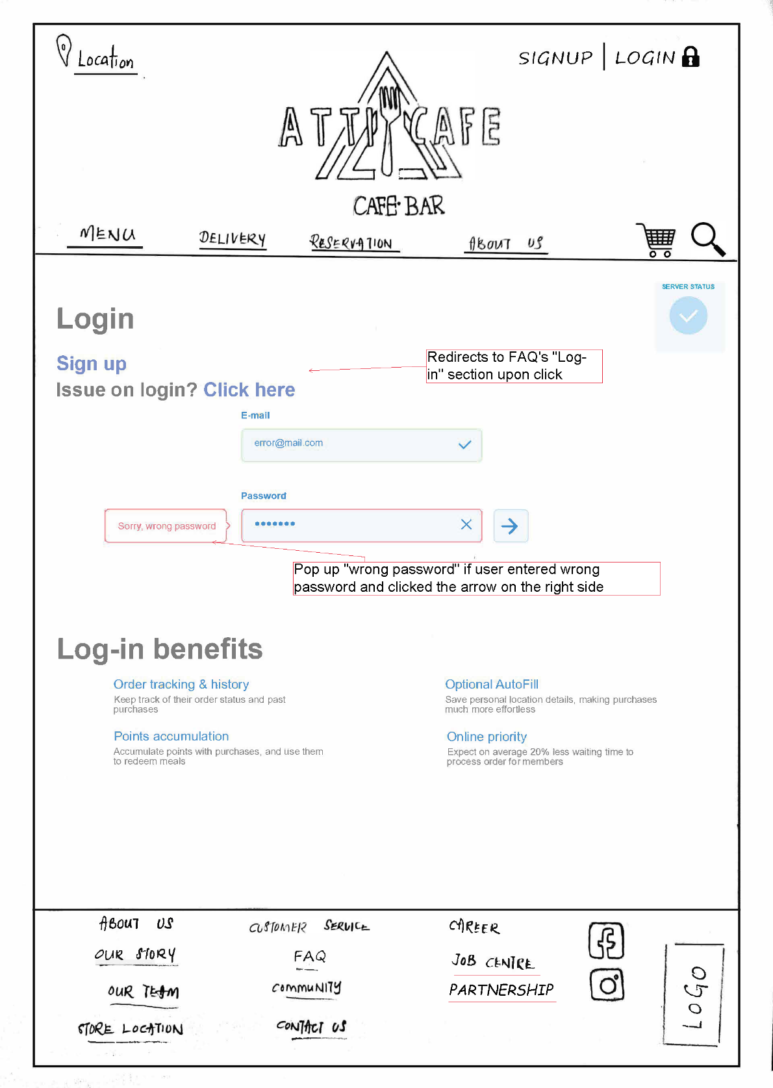

About Us

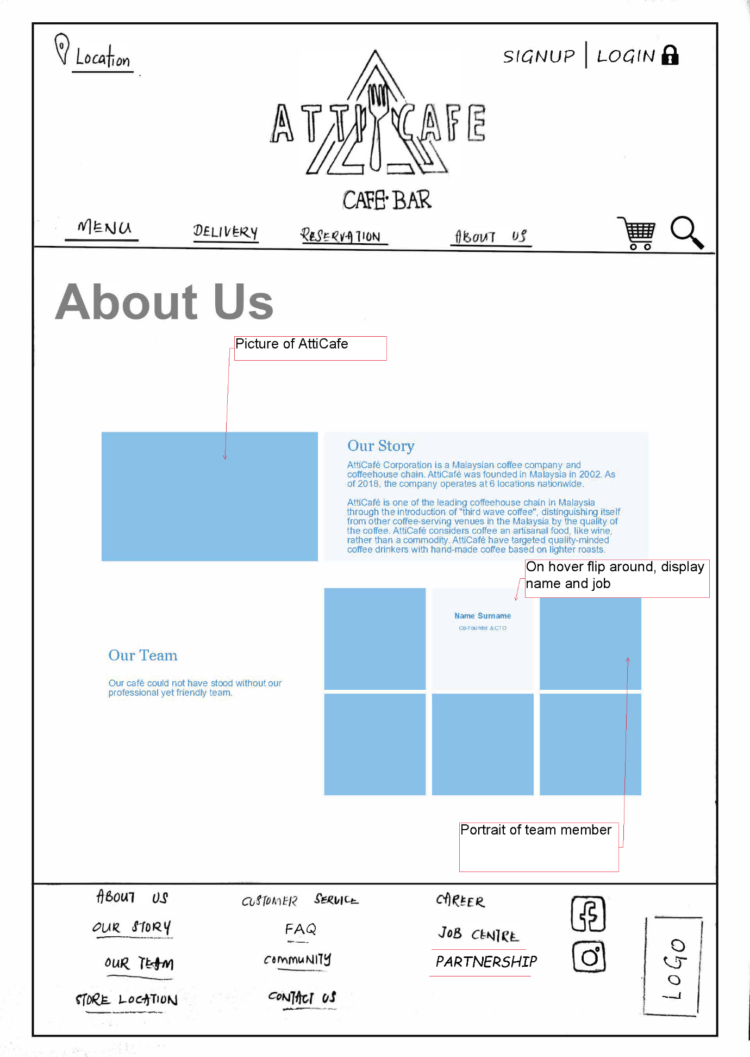

Partnership

